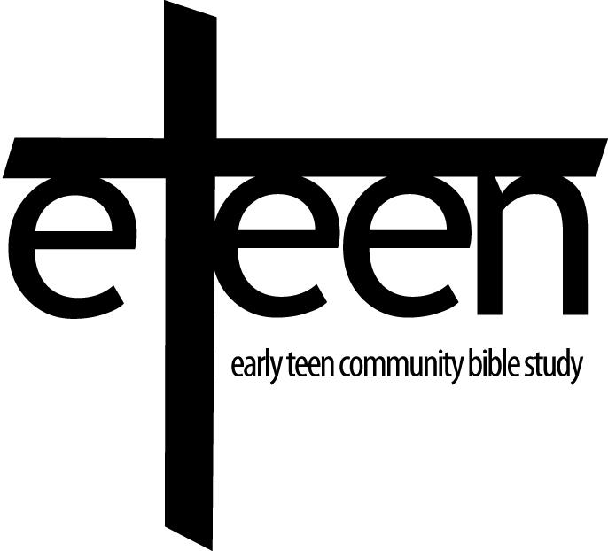
Website: http://northwestindyeteen.cbsclass.org

Making disciples of the Lord Jesus Christ
in our communities through caring,
in-depth Bible study available to all.

eTeen CBS 2018/2019 Calendar

FALL SESSION

Aug 22 Colossians – Lesson 1

Aug 29 Colossians – Lesson 2

Sep 5 Colossians – Lesson 3
(PJ night)

Sep 12 Colossians – Lesson 4

Sep 19 Off-Site Core Group

Sep 26 Colossians – Lesson 5

Oct 3 Colossians Review/Q&A
Bring a Friend Night
(Football night)

Oct 10 Joshua – Lesson 1

Oct 17 FALL BREAK

Oct 24 Joshua – Lesson 2
(Costume night)

Oct 31 BREAK

Nov 7 Joshua – Lesson 3

Nov 14 Joshua – Lesson 4
(College night)

Nov 21 THANKSGIVING BREAK

Nov 28 Joshua – Lesson 5

Dec 5 Joshua – Lesson 6

Dec 12 Christmas Party

DECEMBER 13 to JANUARY 3 – WINTER BREAK

WINTER/SPRING SESSION

Jan 9 Joshua Review/Q&A
Bring a Friend Night

Jan 16 1 John – Lesson 1

Jan 23 1 John – Lesson 2
(PJ night)

Jan 30 1 John – Lesson 3

Feb 6 Off-site Core Group Service Night

Feb 13 1 John – Lesson 4
(Red/White night)

Feb 20 1 John – Lesson 5

Feb 27 1 John Review/Q&A Night

Mar 6 End of Year Party/8th Grade Celebration
(March Madness night)

